Aggregation of OpticsRE sites

Audience
This document will explain advanced functionality of Outback inverter systems. Much of the verbiage used throughout this document will be Outback Power Technologies specific terms. Basic understanding of Outback Power systems components as well as battery based renewable energy systems is essential prior to understanding the concepts discussed here.

Scope/Introduction
Overview: OpticsRE is an online service provided free of charge by Outback Power Technologies that allows users, installers and others to view and configure an Outback system. An Outback system has a limitation of 10 devices such as charge controller/inverters, battery monitors etc. that can be connected to one Mate3 due in part to the 10 inputs on the Hub 10.3. A larger system consisting of more than 10 devices can be designed using separate Mate3 units and separate Hub 10.3 units, though they cannot be connected together for combined data evaluation and system performance monitoring. However, by connecting the Multiple Mate3 units in such systems to the internet and utilizing OpticsRE, one can combine the data from the separate Mate3’s to appear as one system. Note that the stacking limitation of 10 inverters cannot be bypassed and all inverters in a given system must share a Hub10.3.

Fundamentals
To understand the procedure for aggregating multiple “systems” you first need to understand the data structure used in OpticsRE. There are actually four levels to consider in the OpticsRE data tree. The top level would be the “Account”. The account is the first thing you set up and is what gives you access to OpticsRE. When you log into your account, you will see a map showing your all of your Profiles. A profile can be seen as the top level in the OpticsRE data tree. The profile is also what you can give rights to view sites or systems that you have set up or that others have given you rights to access. The next level down from the Profile is the Site. The Site is typically the location in which the system or systems are located. A profile can have multiple sites below it. The final level in the data tree is the System. From a technical standpoint, the Systems can be seen as the Mate3 connected to the internet. There can be multiple systems below each Site.
In the below graphic, we can see a particular Accounts view of his/her profile. The only Profile showing in this case is “Outback Headquarters”. Below the Profile is the Site, in this case “Training Room”. Below the Site are two Systems in this case, “FP-2” and “Radian”.
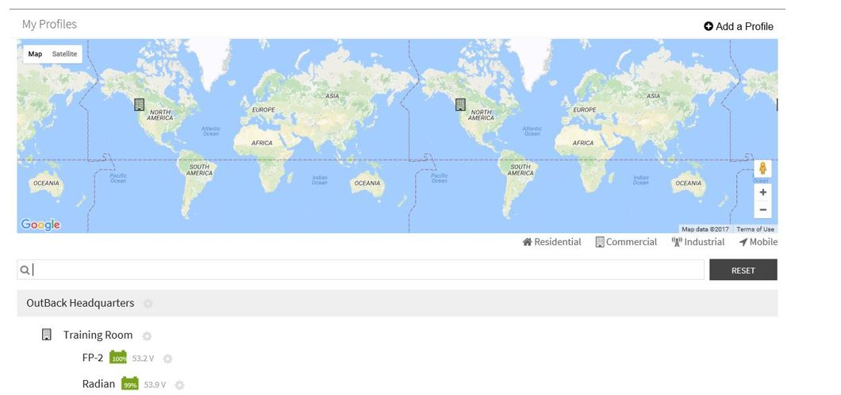

Implementation
There are multiple situations where having either multiple Sites under a profile or multiple Systems under a site can be useful. One scenario would be a user having two completely separate systems in a common location. The second would be a single large system comprising of more than one Mate3/Hub 10.3 combination due to the limitation of 10 inputs on the Hub 10.3. For example a system comprising of 10 Radian GS8048A inverters, nine FM80 charge controllers and a FNDC battery monitor. As all inverters must be on a common Hub for stacking, one Hub would have all 10 inverters, while the second would have the charge controllers and battery monitor connected. In this case, two Mate3 units must be used as well giving you two points of monitoring as opposed to a single aggregated display. If OpticsRE is used in this case, the two Mate3 units, both connected to the internet can be configured under a common “Site” in Optics. In this case the entire systems can be viewed/configured by looking at the “Site” as well as viewing each “System” separately. In the following case, an installer sets up a profile for each of their customers.
Below each customer Profile is a single Site with one or more systems, or Mate3’s connected. The customer or installer can view the multiple systems aggregated under their site. Access can be granted by the installer, who initiated each of their customers profiles, thereby having access for both viewing and configuring each customer.

In the next example below, the installer uses only one profile with each customer having their own Site. This can be problematic as access can only be granted at the Profile level, thereby giving the same level of control and viewing to all other Sites within that Profile. For this reason, it is recommended to configure a separate Profile for each customer.

About OutBack Power Technologies
OutBack Power Technologies is a leader in advanced energy conversion technology. OutBack products include true sine wave inverter/chargers, maximum power point tracking charge controllers, and system communication components, as well as circuit breakers, batteries, accessories, and assembled systems.
Contact Information
Address: | Corporate Headquarters  17825 – 59th Avenue N.E.  Suite B  Arlington, WA 98223 USA | European Office  Hansastrasse 8  D-91126  Schwabach, Germany
Email: | Support@outbackpower.com
Website: | http://www.outbackpower.com

Other
OutBack Power Technologies assumes no responsibility or liability for loss or damage, whether direct, indirect, consequential or incidental, which might arise out of the use of this information. Use of this information is entirely at the user’s risk. OutBack Power Technologies cannot be responsible for system failure, damages, or injury resulting from improper installation of their products.
Information included in this document is subject to change without notice.
© 2017 by OutBack Power Technologies. All Rights Reserved.

